Press Release
April 23, 2020

Announcing the release of The View From the Wrong Side of the Day
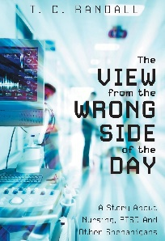First time author, T.C. Randall takes readers on a journey into the fascinating world of health care. It is the story of one man’s journey as an emergency room nurse, as well as the tragic circumstances that led to his departure from the profession.
Although written before the covid-19 pandemic, the author’s story shines a spotlight on many of the systemic inadequacies under which nurses must operate. While some are now praising nurses as front-line heroes, most people are still unaware of the environment in which nurses work, and how this environment directly impacts the mental health of all those who work in the health care field. During the current pandemic, the strain on the system has only gotten worse, and many of the issues that are discussed in the book are now more relevant than ever.
The author also talks about what it is like to suffer with a mental illness, and how inadequate the current level of support for nurses is when they suffer an emotional injury on the job.
At times humorous, at times brutally honest, this book is a must read for anyone currently working on the front lines. It will also speak to anyone working in any high-risk profession, anyone who has a loved one working in one of these professions or anyone who simply sees health care as an important issue.

About the Author
T.C. Randall is a first-time author. He was an emergency room nurse for 14 years before being diagnosed with work related post-traumatic stress two years ago. Currently, he is unable to work, due to his condition. He is already working on a second book.
To reach T.C. Randall, please write to tcrandall@shaw.ca, or he can be contacted through his blog at www.PTSD-in-nursing.com.

